**ADVICE FOR ML**

**DECIDING WHAT TO TRY NEXT**

**Understanding Machine Learning Tools**

* **You have learned various algorithms like linear regression, logistic regression, and deep learning, which are powerful tools for machine learning.**
* **The effectiveness of these tools largely depends on your ability to make informed decisions about the next steps in your project.**

**Making Good Decisions**

* **When facing issues like large prediction errors, you have multiple options to explore, such as acquiring more training data, reducing or adding features, or adjusting regularization parameters.**
* **The key to success is identifying which strategies will yield the best results and investing your time wisely.**

**Using Diagnostics for Improvement**

* **Implementing diagnostics can provide insights into whether collecting more data is worthwhile or if other adjustments are needed.**
* **Although diagnostics may take time to set up, they can ultimately save you significant time and effort by guiding your decisions on improving your learning algorithm's performance.**

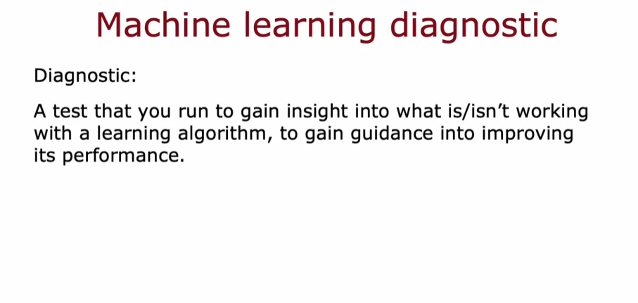

**EVALUATING A MODEL**

**Evaluating Model Performance**

* **To assess a model's performance, it's essential to split the dataset into a training set (typically 70-80% of the data) and a test set (20-30%). This allows for training the model on one subset and evaluating it on another.**
* **The training error (J_train) measures how well the model performs on the training set, while the test error (J_test) indicates how well it generalizes to unseen data.**

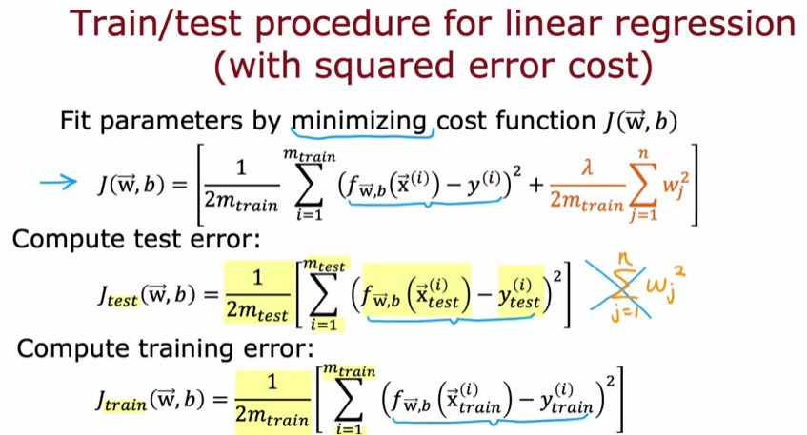

**Understanding Errors**

* **A model may fit the training data well (low J_train) but perform poorly on the test set (high J_test), indicating overfitting. This highlights the need for a balance between fitting the training data and generalizing to new examples.**
* **For regression tasks, the squared error cost function is used, while for classification tasks, logistic loss or misclassification rates can be employed to evaluate performance.**

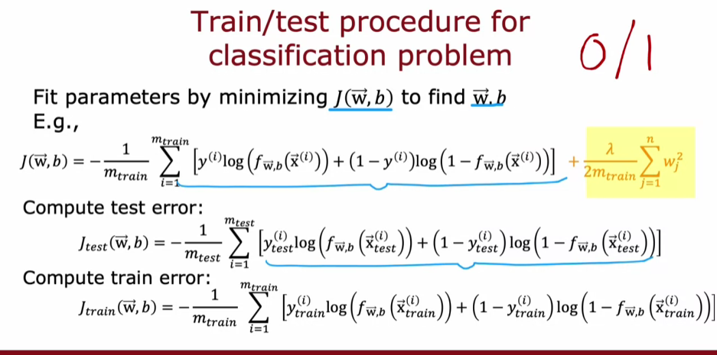

**Reinforcing Learning**

* **By computing both J_train and J_test, you can systematically evaluate your learning algorithm's effectiveness. This process is crucial for selecting the appropriate model for specific machine learning applications.**

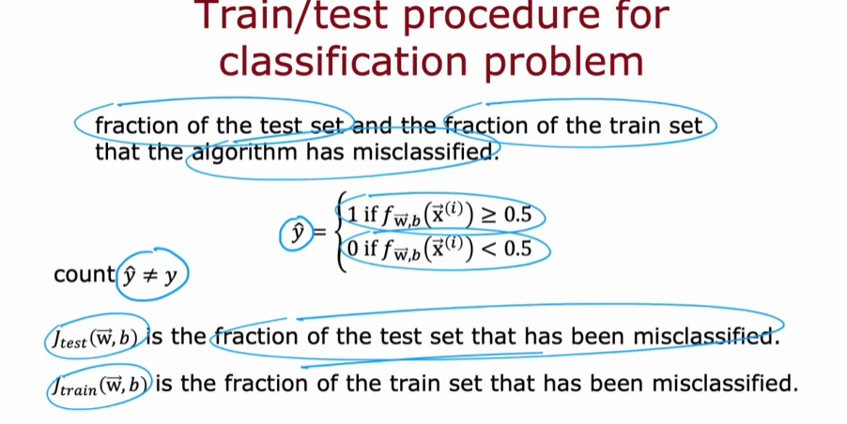

**MODEL SELECTION AND TRAINING**

**Understanding Model Evaluation**

* **Training error alone may not accurately reflect a model's ability to generalize to new data, as it can be overly optimistic.**
* **The test set provides a better estimate of generalization error by evaluating the model on unseen examples.**

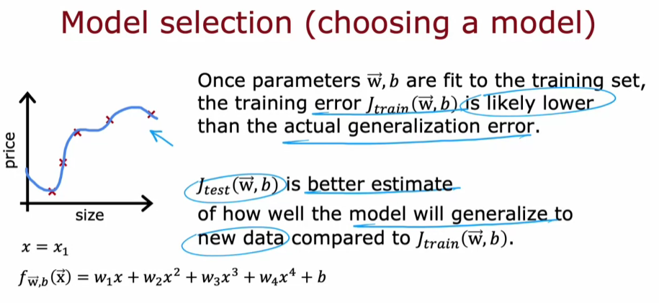

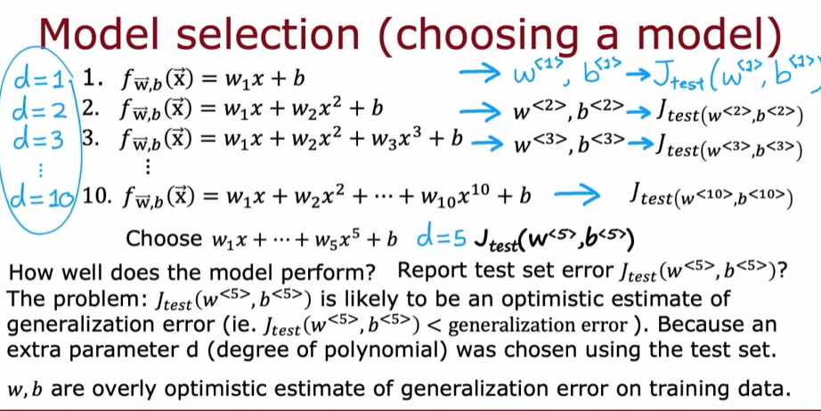

**Model Selection Procedure**

* **To improve model selection, data should be split into three subsets: training set, cross-validation set, and test set.**
* **The cross-validation set is used to evaluate different models and select the one with the lowest cross-validation error, ensuring that the test set remains a fair estimate of generalization error.**

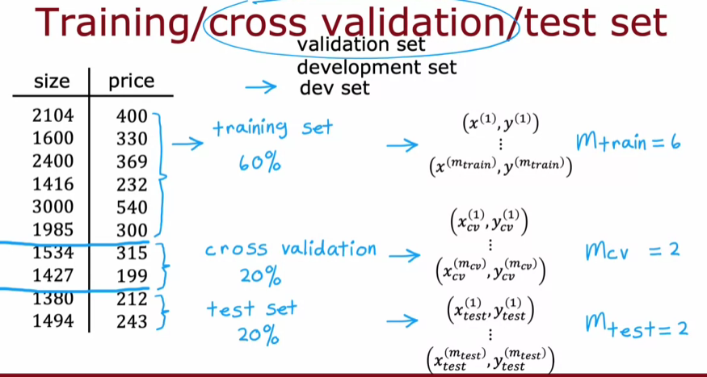

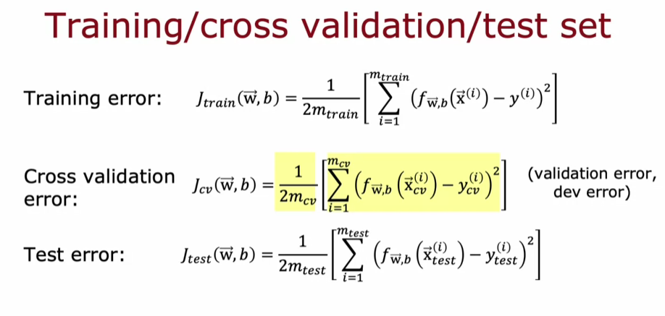

**Best Practices in Model Selection**

* **Decisions regarding model parameters and architecture should be made using only the training and cross-validation sets, avoiding any influence from the test set.**
* **After selecting the best model, the test set can be used to report the generalization error, providing a reliable assessment of the model's performance on new data.**

